[Your Address]

[School Address]

[Date]

Re: BelongTo Quality Mark programme and Stand Up Week

Dear Principal, Staff and Board of Management, (copy your local TDs and Minister Norma Foley)

I/we would like to state our strong objection to xxx school partaking in the BelongTo Quality Mark award and/or Stand Up Awareness Week and we do not consent for our son(s)/daughter(s) to partake in any classes or activities related to these programmes/events.

I/we have serious reservations about the motivations and influences of BelongTo, who are a powerful activist group with a specific agenda and considerable influence over government Departments, politicians, teaching bodies and unions, schools and youth organisations. They are a large corporate NGO with significant funds available to them[1]. We do not believe they have the best interests of our children at heart. For such a group to judge the ‘quality’ of a school and to influence the direction of our children’s education is entirely wrong.

The recently released video of an interview with a whistle-blower teacher[2], who attended a year-long DCU training course, and also the OIDE in-service training, for SPHE teachers has highlighted the dangers of allowing promoters of extreme sex education and activists to influence teacher training or dictate what our children in schools are taught and exposed to.

It is of course very important that ALL students, including those from minority groups, should feel safe and supported in the school environment. Bullying of any kind should never be tolerated. However, it is also important that all students should be treated equally. To encourage labelling of students and to elevate the status of one particular minority group over any other, leads to preferential treatment for that group and inequality for other students.

We are particularly concerned about the promotion of transgender ideology – e.g. that a boy could become a girl (and vice versa) neither or both - in schools which seems to be a priority for BelongTo and other LGBTQ+ activist groups such as TENI. Teaching this ideology to children as though it were fact and disregarding the biological facts has the potential to cause confusion and harm to vulnerable teenagers. Many teenagers are struggling to come to terms with their changing bodies and suffer from lack of confidence and self-esteem. Offering transgenderism as an answer to all their problems rather than supporting them to be comfortable with who they are is irresponsible and has the potential to cause major harm.

On this issue we would like to bring to your attention the recently published definitive Report by Dr Hilary Cass on the treatment of children with gender dysphoria[3]. In an article for the Journal.ie[4], Dr Paul Moran who was part of Hilary Cass’s team and an Irish psychiatrist with years of experience treating gender distress, describes the Cass Report as “*the most comprehensive review of available evidence, experience and expertise ever conducted*”. As such it cannot be ignored. In the light of this Report, Dr Moran states that “*the Department of Health should reconsider some of the overly affirmative educational and training materials it is sending to schools and the prominent role it has given to activist organisations in policy development and teacher training*”.

Following the publication of the Cass Report, the UK Department of Education published new guidance[5] to ensure that the content of Relationships, Sexuality and Health Education lessons ‘*is factual, appropriate and that children have the capacity to fully understand everything they are being taught.’* The guidance stressed that parents should have to see all resources being used. It stated that ‘*The contested theory of gender identity will not be taught.’*

We find it incomprehensible that the Irish Department of Education, the NCCA, the Joint Managerial Body for voluntary Secondary Schools and Irish schools, seemingly see fit to ignore the advice contained in the Cass report, put together by a team of experts in the field, preferring instead to continue to follow the directions and ideologies of activists and activist groups such as BelongTo and TENI.

Gender dysphoria is a psychological condition, not a lifestyle choice or fashion statement. However, the constant promotion and celebration of transgenderism by groups such as TENI and BelongTo is leading to the unprecedented social contagion referred to by the Cass Report.

The Cass Report states categorically that social transitioning, including changing names and pro-nouns, is not a neutral act but a form of intervention which should not be undertaken lightly and only ever under the supervision of a clinical expert. Yet, activist groups such as BelongTo promote the affirmation of transgender identities, including social transitioning and advise schools and teachers to follow this path. On the issue of transgenderism, schools must remain neutral and insist that proper licensed clinical advice is sought for a child suffering from gender dysphoria, not the advice of an activist group pushing a radical agenda. Dr Moran is very clear that “*Irish schools should not be taking the lead in the social transitioning of children*”.

Social transitioning can lead a child down the path towards irreversible life changing hormone treatment, puberty blockers use or even surgery: this is the so called ‘transgender healthcare’ which activist groups such as BelongTo are lobbying to make freely available to children and young adults in Ireland. On this issue, the Cass Report states that “*for the majority of young people, a medical pathway may not be the best way*”.

There is an increasing number of young people, often referred to as ‘detransitioners’, who regret medically transitioning to the opposite gender. Some of these brave young people are now speaking out about how they were rushed into making permanent life changing decisions at a young age when they were not able to fully understand the consequences[6]. It is notable that while transgender children are welcomed into BelongTo and similar communities with open arms, no such supports are available to ‘detransitioners’ who often find themselves shunned and treated as outcasts.

Concerning testimonies[7] [8] are now emerging from young people who attended BelongTo youth groups, which state that young gay teenagers are pressurised to identify as transgender and celebrated for doing so. This illuminates BelongTo as an organisation who, rather than supporting gay teenagers to be comfortable with who they are, suggests to them that they are actually transgender.

We are very concerned that BelongTo also engage in training for teachers and youth workers. The following small excerpt from a teacher training manual appears to be giving advice in direct opposition to the recommendations of the Cass Report on social transitioning, and seems to be advising teachers to lie to parents about their children.

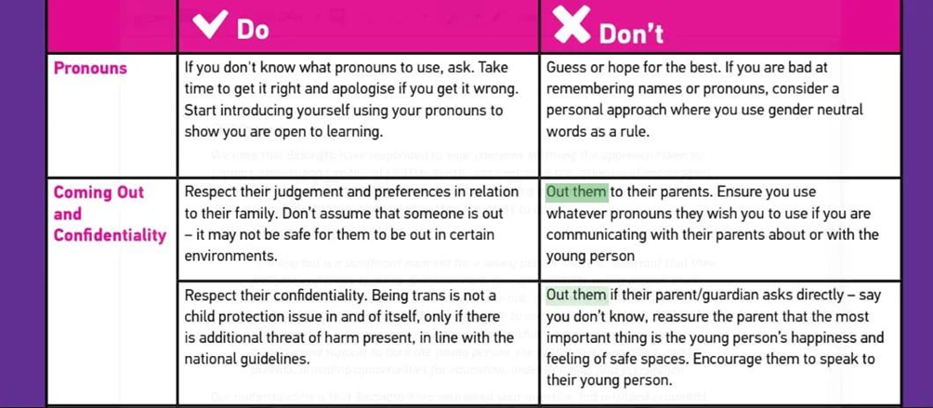

Gender Dysphoria is a psychological condition that legally must not be kept hidden from a child’s parent. To suggest that a child could be unsafe or at risk of “harm” from their family if their parents and legal guardians are advised of this condition is extremely controversial and divisive. If any child is at risk of actual harm, then this is a separate child protection issue and should be reported to Tusla, as all teachers, who have child protection training will know.

I/We would like to remind you that in accordance with section 9 (d) of the Education Act 1998 [9], a school is obliged to:

(d) promote the moral, spiritual, social and personal development of students and provide health education for them, **in consultation with their parents**, having regard to the characteristic spirit of the school, (emphasis added)

Any outside body, such as Belong To or TENI, who will have influence over the moral, spiritual, social and personal development of students in XX school should therefore only ever be engaged following full consultation with parents, who in this instance should be party to all of the information included in this letter.

Please respond promptly to this communication to acknowledge receipt of this letter and confirm that your school will cease engagement with BelongTo pending a full investigation in light of the serious matters highlighted above and a full consultation with all parents. I/we request that a full Risk Assessment is carried out in relation to the child safeguarding issues noted above, and in particular in relation to Stand Up Week and the BelongTo Quality Mark be shared with all parents.

Yours Sincerely

[Your Name]

1. https://www.belongto.org/funding-governance/annual-reports/belong-to-annual-report-2022/
2. https://www.naturalwomenscouncil.ie/petition
3. https://cass.independent-review.uk/home/publications/final-report/
4. https://www.thejournal.ie/readme/tavistock-cass-report-ireland-6356357-Apr2024/
5. https://www.gov.uk/government/news/age-limits-introduced-to-protect-children-in-rshe
6. https://nypost.com/2022/06/18/detransitioned-teens-explain-why-they-regret-changing-genders/
7. https://twitter.com/gcraughwell/status/1702746240578916433?s=48&t=YCL0YmFgN0UeIYO9zaE0_w
8. https://m.independent.ie/irish-news/lesbian-activist-raises-concerns-about-belong-to-youth-meetings/a319171930.html
9. https://www.irishstatutebook.ie/eli/1998/act/51/enacted/en/html